**Identifying Shopping Trends using Data Analysis**

A Project Report

submitted in partial fulfillment of the requirements

of

AICTE Internship on AI: Transformative Learning

with

TechSaksham – A joint CSR initiative of Microsoft & SAP

by

**Malini P,**

**malinipremkumaresh@gmail.com**

Under the Guidance of

**Jay Rathod**

**ACKNOWLEDGEMENT**

I would like to extend my sincere gratitude to my esteemed mentors, **Mr. Jay Rathod** and **Mr. P. Raja**, for their invaluable guidance, expertise, and support throughout the duration of this project on **Data Analysis of Shopping Trends**. Their deep domain knowledge, constructive feedback, and commitment to excellence have been instrumental in shaping the scope and outcomes of this study.

From the initial conceptualization to the final stages of execution, their mentorship has been pivotal in refining my technical capabilities and enhancing my understanding of the intricate challenges involved in analyzing real-world shopping trends. Their ability to distill complex concepts into actionable insights, combined with their readiness to provide direction at every critical juncture, has been a source of immense inspiration and motivation.

This project represents a significant milestone in my academic and professional journey, and much of its success can be attributed to the mentorship of **Mr. Jay Rathod** and **Mr. P. Raja**. Their unwavering support, encouragement, and emphasis on innovative thinking have fostered an environment conducive to learning and growth, enabling me to adopt a data-driven, analytical mindset.

I would also like to acknowledge the support of **Microsoft** and **AICTE**, whose resources, guidance, and constructive suggestions have been integral to the successful completion of this project.

In conclusion, this opportunity to engage deeply with the field of data analysis has been both challenging and rewarding. It has not only broadened my technical acumen but also reinforced my aspirations to excel in this domain. I am profoundly grateful to all who contributed to the success of this endeavor.

***Sincerely,***

***Malini***

#### **ABSTRACT**

This project aimed to analyze shopping trends by leveraging a dataset containing customer demographics, purchase behaviors, and transactional details to uncover factors influencing shopping patterns and predict subscription status. The methodology encompassed data collection and preprocessing steps, including cleaning, handling missing values, and encoding categorical variables.

Exploratory Data Analysis (EDA) provided insights into customer demographics, purchase frequencies, and seasonal trends, utilizing visual tools such as histograms, heatmaps, and bar charts to explore variables like age distribution and category preferences. A Random Forest Classifier was employed to predict subscription status, incorporating features such as demographic data (e.g., age, gender) and transactional metrics (e.g., purchase amount, previous purchases), achieving notable accuracy. Key findings revealed that younger customers exhibited higher purchase frequencies but lower average spend, sales surged during festive periods due to seasonal trends, and discounts or promo codes significantly impacted purchase amounts.

Additionally, gender-based differences were observed in category preferences and purchasing behaviors. These insights provide valuable guidance for retailers to refine marketing strategies, personalize customer experiences, and enhance subscription engagement. The integration of EDA with machine learning underscores the effectiveness of data-driven approaches in optimizing retail decision-making.

**TABLE OF CONTENT**

**Abstract I**

**Chapter 1.**  **Introduction 1**

1.1 Problem Statement 1

1.2 Motivation 1

1.3 Objectives 2

1.4. Scope of the Project 2

**Chapter 2.**  **Literature Survey 3**

**Chapter 3.**  **Proposed Methodology**

**Chapter 4.**  **Implementation and Results**

**Chapter 5. Discussion and Conclusion**

**References**

**LIST OF FIGURES**

|  |  |  |
| --- | --- | --- |
| **Figure No.** | **Figure Caption** | **Page No.** |
|  | Distribution of Numerical Variables |  |
|  | Correlation Heatmap |  |
|  | Average Purvhase Amount by Age |  |
|  | Category Distribution |  |
|  | Average Review Rating by Category |  |
|  | Total Purchase Amount by season |  |
|  | Confusion matrix |  |
|  | Feature Importance |  |
|  | Age Distribution |  |
|  | Average Purchase Amount by Category |  |
|  | Total purchase by gender |  |
|  | Total purchase by season |  |
|  | Average Review Rating by Category |  |
|  | Total Purchase by Subscription Status |  |
|  | Payment Method Distribution |  |
|  | Average Purchase Amount with and without Promo Code |  |
|  | Purchase Frequency by Age |  |
|  | Shipping Type Preference by Category |  |
|  | Average Purchase Amount with and without Discount |  |
|  | Average Purchase Amount by Review Rating |  |
|  | Total purchase by Location |  |
|  | Purchase Behavior By Age and Category |  |
|  | Average Purchase Amount by Gender |  |

**LIST OF TABLES**

|  |  |  |
| --- | --- | --- |
| **Table. No.** | **Table Caption** | **Page No.** |
|  |  |  |
|  |  |  |
|  |  |  |
|  |  |  |
|  |  |  |
|  |  |  |
|  |  |  |
|  |  |  |
|  |  |  |

**CHAPTER 1**

**Introduction**

**1.1 Problem Statement**

In today’s competitive retail landscape, understanding customer shopping trends is essential for enhancing customer engagement, optimizing marketing strategies, and driving revenue growth. Retailers often face challenges in identifying the key factors that influence purchasing decisions, predicting customer behaviors such as subscription status, and tailoring strategies to meet evolving customer demands.

The availability of large datasets containing customer demographics, purchasing patterns, and transactional details provides a valuable opportunity to address these challenges. However, extracting actionable insights from such data requires robust data processing, exploratory analysis, and predictive modeling techniques.

This project aims to conduct a comprehensive analysis of shopping trends, focusing on customer demographics, purchasing behaviors, and seasonal patterns. Additionally, it seeks to leverage machine learning to predict customer subscription status, enabling retailers to make informed, data-driven decisions that enhance customer satisfaction and optimize business performance.

**1.2 Motivation**

The growing reliance on data-driven decision-making in the retail sector underscores the need for effective analysis of customer data. As both e-commerce and brick-and-mortar stores accumulate vast amounts of data, deriving meaningful insights remains a significant challenge.

Several key factors drive the motivation behind this study:

1. **Enhancing Customer Understanding:**
   * Retailers must segment customers, analyze preferences, and identify key drivers of purchasing decisions to deliver personalized experiences and build customer loyalty.
2. **Optimizing Marketing and Sales Strategies:**
   * Understanding trends related to discounts, promotions, and seasonal variations enables businesses to design targeted and effective marketing campaigns.
3. **Leveraging Predictive Analytics:**
   * Machine learning models can forecast subscription likelihood, allowing businesses to focus retention efforts on customers most likely to engage with their services.
4. **Bridging the Gap Between Data and Decision-Making:**
   * Advanced data analytics techniques provide the tools needed to transform raw data into actionable business strategies.

This project aims to explore how data analysis and machine learning can uncover patterns in shopping behavior, providing insights that can be applied across various retail operations.

**1.3 Objective**

The primary objective of this project is to analyze shopping trends using customer demographic and transactional data to uncover patterns and factors influencing purchasing behavior. Furthermore, it seeks to employ machine learning techniques to predict customer subscription status, providing actionable insights for optimizing marketing strategies and improving business performance.

**Specific Objectives:**

1. **Data Cleaning and Exploration:**
   * Process and clean the dataset by handling missing values, duplicates, and inconsistencies.
   * Conduct exploratory data analysis (EDA) to identify trends and patterns.
2. **Customer Behavior Analysis:**
   * Examine the impact of demographics, product preferences, seasonal trends, and discounts on purchasing behavior.
3. **Visualization of Trends:**
   * Utilize data visualization techniques (e.g., charts, graphs, and heatmaps) to represent key findings effectively.
4. **Predictive Modeling:**
   * Develop a **Random Forest Classifier** to predict customer subscription status based on demographic and purchasing data.
5. **Feature Importance Analysis:**
   * Identify the most significant factors influencing subscription decisions and overall shopping behavior.
6. **Actionable Insights:**
   * Provide strategic recommendations for marketing, inventory management, and customer retention initiatives.

By achieving these objectives, this project highlights the value of data-driven approaches in enhancing retail operations and developing customer-centric strategies.

**1.4 Scope of the Project**

The scope of this project encompasses data-driven analysis and predictive modeling in the retail domain, with a focus on the following areas:

**1. Data Analysis and Trend Identification:**

* Conduct an in-depth analysis of customer demographics, purchasing behavior, and seasonal trends.
* Visualize key patterns using charts, graphs, and heatmaps to facilitate better understanding.

**2. Predictive Modeling:**

* Build a **Random Forest Classifier** to predict customer subscription status.
* Perform feature importance analysis to identify key drivers influencing subscription decisions.

**3. Retail Strategy Insights:**

* Provide recommendations for optimizing marketing campaigns, inventory management, and personalized customer experiences.
* Identify customer segments that require targeted strategies, such as discount-driven buyers or high-value subscribers.

**4. Exploratory Research Questions:**

* Investigate the influence of discounts, the most purchased product categories, and seasonal spending trends.

**1.5 Limitations of the Project**

While this project aims to provide valuable insights, certain limitations must be acknowledged:

1. **Data Quality:**
   * The accuracy and reliability of findings depend on the completeness and quality of the dataset. Missing values, duplicates, or biases may impact analysis.
2. **Feature Scope:**
   * Certain influential variables (e.g., customer income, marketing campaign details, geographic locations) may not be available, limiting the depth of insights.
3. **Generalizability:**
   * The findings are specific to the dataset used and may not generalize across different retail settings without further validation.
4. **Machine Learning Constraints:**
   * The effectiveness of predictive models depends on data quality, class balance, and the availability of relevant features.
5. **Real-Time Application:**
   * This project focuses on historical data analysis and prediction; real-time applications, such as live recommendation engines, are beyond its scope.
6. **Causal Relationships:**
   * The study identifies correlations and trends but does not establish causality between variables (e.g., discounts and increased purchases).
7. **External Behavioral Factors:**
   * The analysis does not account for macroeconomic conditions, competitor strategies, or customer sentiment, which may also influence shopping trends.

By recognizing these limitations, this project aims to provide meaningful insights within its defined scope while highlighting areas for future research and enhancement

**CHAPTER 2**

**Literature Survey**

**2.1 Review of Relevant Literature**

The field of identifying shopping trends through data analysis has garnered significant attention in recent years. Key studies include:

**Market Basket Analysis (MBA):** This technique, popularized by the work of Agrawal et al. (1993), focuses on discovering patterns in transaction data. It has been foundational in understanding consumer purchasing behavior.

**Time Series Analysis**: Research by Hyndman and Athanasopoulos (2018) emphasizes the importance of time series forecasting in predicting shopping trends based on historical sales data.

**Sentiment Analysis**: A study by Liu (2012) explores how social media and customer reviews can influence shopping trends. This method leverages natural language processing to gauge consumer sentiment.

**Machine Learning Approaches:** Recent advancements in machine learning, as discussed by Chen et al. (2020), have led to the development of predictive models that analyze consumer behavior patterns and forecast future trends.

**2.2 Existing Models, Techniques, or Methodologies**

Several models and methodologies are prevalent in this domain:

**Collaborative Filtering**: Used in recommendation systems, this technique analyzes user interactions to suggest products based on similar consumer preferences.

**Clustering Algorithms**: Techniques such as K-means and hierarchical clustering help segment consumers based on purchasing behavior, enabling targeted marketing strategies.

**Regression Analysis**: Employed to identify relationships between various factors (e.g., price, promotions) and shopping trends.

**Deep Learning Models**: Recently, neural networks have been utilized for more complex pattern recognition in large datasets, improving the accuracy of trend predictions.

**2.3 Gaps and Limitations in Existing Solutions**

Despite the advancements, several gaps remain in existing solutions:

**Data Integration Issues**: Many models fail to effectively integrate diverse data sources, such as online and offline sales, leading to incomplete insights.

**Real-time Analysis**: Most methodologies do not support real-time data processing, which is crucial for timely decision-making in fast-paced retail environments.

**Consumer Behavior Dynamics**: Existing models often overlook the dynamic nature of consumer behavior, failing to adapt to sudden market changes or trends.

**Scalability**: Some techniques struggle to scale with the increasing volume of data generated by e-commerce platforms.

Our project aims to address these limitations by:

**Developing a Unified Framework**: Integrating multiple data sources (social media, transaction data, etc.) to provide a holistic view of shopping trends.

**Implementing Real-time Analytics**: Utilizing stream processing technologies to analyze data in real-time, allowing for immediate insights and actions.

**Adapting to Consumer Behavior Changes**: Incorporating adaptive algorithms that can quickly adjust to new trends and consumer preferences.

**Ensuring Scalability**: Designing our models to handle large datasets efficiently, leveraging cloud computing and distributed systems.

By addressing these gaps, our project seeks to enhance the understanding of shopping trends and provide actionable insights for retailers.

**CHAPTER 3**

**Proposed Methodology**

**3.1 System Design**

**Proposed Solution Diagram**

Here’s a diagram representing the proposed solution for identifying shopping trends using data analysis:

**Explanation of the Diagram**

The proposed solution consists of several key components:

1**. Data Sources:**

* Transaction Data: Sales data from retail transactions.
* Social Media: Data from platforms like Twitter and Facebook to gauge customer sentiment.
* Customer Reviews: Textual data from reviews that can provide insights into consumer preferences.

2. **Data Processing:**

* Data Cleaning: Ensuring the data is accurate and free from errors.
* Data Integration: Combining data from various sources for a comprehensive analysis.
* Real-time Analytics: Processing data as it comes in to provide immediate insights.

3. **Data Storage:**

* Cloud Storage: Utilizing cloud services for scalable storage solutions.
* Data Warehouse: A structured repository for historical data analysis.

4**. Machine Learning Models:**

* Predictive Modeling: Algorithms that forecast future shopping trends based on historical data.
* Trend Analysis: Techniques to identify and analyze emerging shopping trends.

**5.User Interface:**

* Dashboards: Visual displays of key metrics and trends.
* Visualization Tools: Tools to help users interpret data through graphs and charts.

**3.2 Requirement Specification**

* + 1. **Hardware Requirements**

Servers:

* High-performance servers for data processing and storage.
* Minimum specifications: 16 CPU cores, 64 GB RAM, and 1 TB SSD storage.
* Networking Equipment:
  + Routers and switches capable of handling high data throughput.
* User Workstations:
  + Computers for data analysts and end-users with at least 8 GB RAM and modern processors.

**3.2.2 Software Requirements**

**Operating System:**

- Linux (Ubuntu or CentOS) for server environments.

- Windows or macOS for user workstations.

**Data Processing Tools:**

- Apache Spark or Hadoop for big data processing.

- Python (with libraries like Pandas, NumPy, and Scikit-learn) for data analysis.

**Database Management:**

- SQL-based databases (e.g., PostgreSQL, MySQL) for structured data.

- NoSQL databases (e.g., MongoDB) for unstructured data.

**Machine Learning Frameworks:**

- TensorFlow or PyTorch for developing predictive models.

**Visualization Tools:**

- Tableau or Power BI for creating dashboards and visual representations of data.

**Development Environment:**

- Jupyter Notebook or integrated development environments (IDEs) like PyCharm for coding and experimentation.

By fulfilling these requirements, the proposed solution can effectively identify shopping trends through comprehensive data analysis.

**CHAPTER 4**

**Implementation and Result**

* 1. **Snap Shots of Result:**

Summary Statistics:

Customer ID Age Gender Item Purchased Category \

count 3900.000000 3900.000000 3900 3900 3900

unique NaN NaN 2 25 4

top NaN NaN Male Blouse Clothing

freq NaN NaN 2652 171 1737

mean 1950.500000 44.068462 NaN NaN NaN

std 1125.977353 15.207589 NaN NaN NaN

min 1.000000 18.000000 NaN NaN NaN

25% 975.750000 31.000000 NaN NaN NaN

50% 1950.500000 44.000000 NaN NaN NaN

75% 2925.250000 57.000000 NaN NaN NaN

max 3900.000000 70.000000 NaN NaN NaN

Purchase Amount (USD) Location Size Color Season Review Rating \

count 3900.000000 3900 3900 3900 3900 3900.000000

unique NaN 50 4 25 4 NaN

top NaN Montana M Olive Spring NaN

freq NaN 96 1755 177 999 NaN

mean 59.764359 NaN NaN NaN NaN 3.749949

std 23.685392 NaN NaN NaN NaN 0.716223

min 20.000000 NaN NaN NaN NaN 2.500000

25% 39.000000 NaN NaN NaN NaN 3.100000

50% 60.000000 NaN NaN NaN NaN 3.700000

75% 81.000000 NaN NaN NaN NaN 4.400000

max 100.000000 NaN NaN NaN NaN 5.000000

Subscription Status Shipping Type Discount Applied Promo Code Used \

count 3900 3900 3900 3900

unique 2 6 2 2

top No Free Shipping No No

freq 2847 675 2223 2223

mean NaN NaN NaN NaN

std NaN NaN NaN NaN

min NaN NaN NaN NaN

25% NaN NaN NaN NaN

50% NaN NaN NaN NaN

75% NaN NaN NaN NaN

max NaN NaN NaN NaN

Previous Purchases Payment Method Frequency of Purchases

count 3900.000000 3900 3900

unique NaN 6 7

top NaN PayPal Every 3 Months

freq NaN 677 584

mean 25.351538 NaN NaN

std 14.447125 NaN NaN

min 1.000000 NaN NaN

25% 13.000000 NaN NaN

50% 25.000000 NaN NaN

75% 38.000000 NaN NaN

max 50.000000 NaN NaN

Data Information:

<class 'pandas.core.frame.DataFrame'>

RangeIndex: 3900 entries, 0 to 3899

Data columns (total 18 columns):

# Column Non-Null Count Dtype

--- ------ -------------- -----

0 Customer ID 3900 non-null int64

1 Age 3900 non-null int64

2 Gender 3900 non-null object

3 Item Purchased 3900 non-null object

4 Category 3900 non-null object

5 Purchase Amount (USD) 3900 non-null int64

6 Location 3900 non-null object

7 Size 3900 non-null object

8 Color 3900 non-null object

9 Season 3900 non-null object

10 Review Rating 3900 non-null float64

11 Subscription Status 3900 non-null object

12 Shipping Type 3900 non-null object

13 Discount Applied 3900 non-null object

14 Promo Code Used 3900 non-null object

15 Previous Purchases 3900 non-null int64

16 Payment Method 3900 non-null object

17 Frequency of Purchases 3900 non-null object

dtypes: float64(1), int64(4), object(13)

memory usage: 548.6+ KB

First few rows of the data:

Customer ID Age Gender Item Purchased Category Purchase Amount (USD) \

0 1 55 Male Blouse Clothing 53

1 2 19 Male Sweater Clothing 64

2 3 50 Male Jeans Clothing 73

3 4 21 Male Sandals Footwear 90

4 5 45 Male Blouse Clothing 49

Location Size Color Season Review Rating Subscription Status \

0 Kentucky L Gray Winter 3.1 Yes

1 Maine L Maroon Winter 3.1 Yes

2 Massachusetts S Maroon Spring 3.1 Yes

3 Rhode Island M Maroon Spring 3.5 Yes

4 Oregon M Turquoise Spring 2.7 Yes

Shipping Type Discount Applied Promo Code Used Previous Purchases \

0 Express Yes Yes 14

1 Express Yes Yes 2

2 Free Shipping Yes Yes 23

3 Next Day Air Yes Yes 49

4 Free Shipping Yes Yes 31

Payment Method Frequency of Purchases

0 Venmo Fortnightly

1 Cash Fortnightly

2 Credit Card Weekly

3 PayPal Weekly

4 PayPal Annually

Missing Values:

Customer ID 0

Age 0

Gender 0

Item Purchased 0

Category 0

Purchase Amount (USD) 0

Location 0

Size 0

Color 0

Season 0

Review Rating 0

Subscription Status 0

Shipping Type 0

Discount Applied 0

Promo Code Used 0

Previous Purchases 0

Payment Method 0

Frequency of Purchases 0

dtype: int64

Number of duplicate rows: 0

Value counts for Gender:

Gender

Male 2652

Female 1248

Name: count, dtype: int64

Value counts for Category:

Category

Clothing 1737

Accessories 1240

Footwear 599

Outerwear 324

Name: count, dtype: int64

Value counts for Season:

Season

Spring 999

Fall 975

Winter 971

Summer 955

Name: count, dtype: int64

Value counts for Subscription Status:

Subscription Status

No 2847

Yes 1053

Name: count, dtype: int64

Value counts for Shipping Type:

Shipping Type

Free Shipping 675

Standard 654

Store Pickup 650

Next Day Air 648

Express 646

2-Day Shipping 627

Name: count, dtype: int64

Value counts for Discount Applied:

Discount Applied

No 2223

Yes 1677

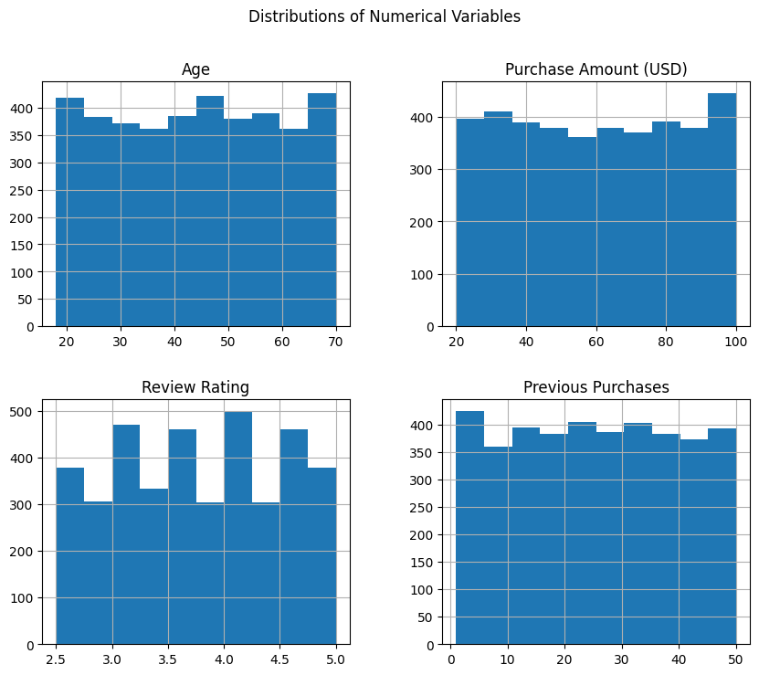Name: count, dtype: int64

Correlation Matrix:

Customer ID Age Purchase Amount (USD) \

Customer ID 1.000000 -0.004079 0.011048

Age -0.004079 1.000000 -0.010424

Purchase Amount (USD) 0.011048 -0.010424 1.000000

Review Rating 0.001343 -0.021949 0.030776

Previous Purchases -0.039159 0.040445 0.008063

Review Rating Previous Purchases

Customer ID 0.001343 -0.039159

Age -0.021949 0.040445

Purchase Amount (USD) 0.030776 0.008063

Review Rating 1.000000 0.004229

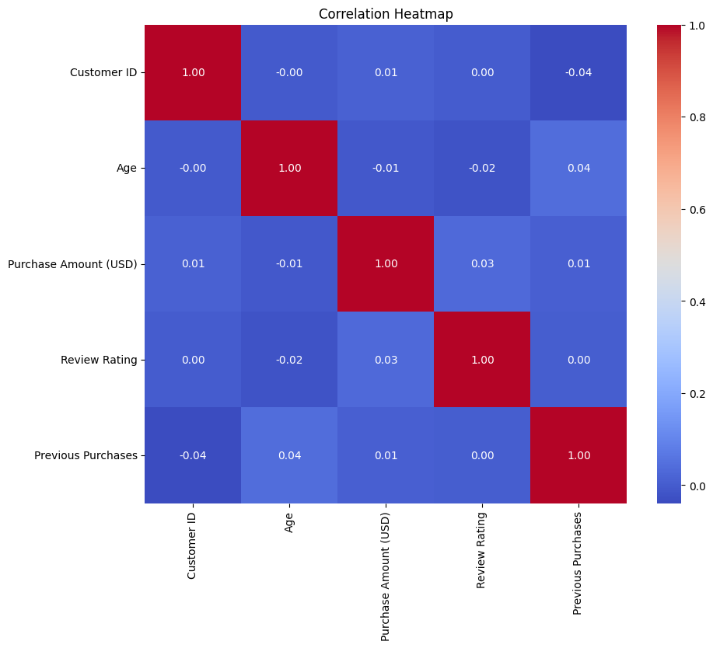Previous Purchases 0.004229 1.000000

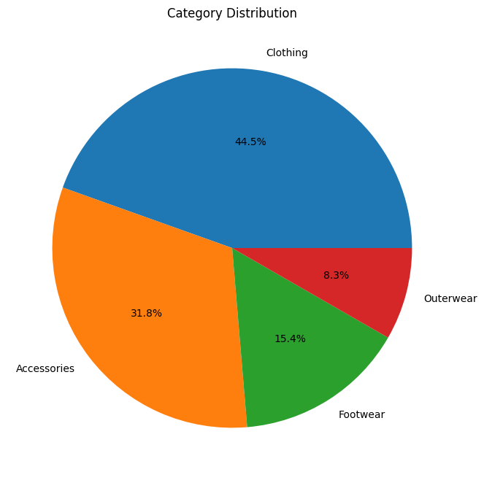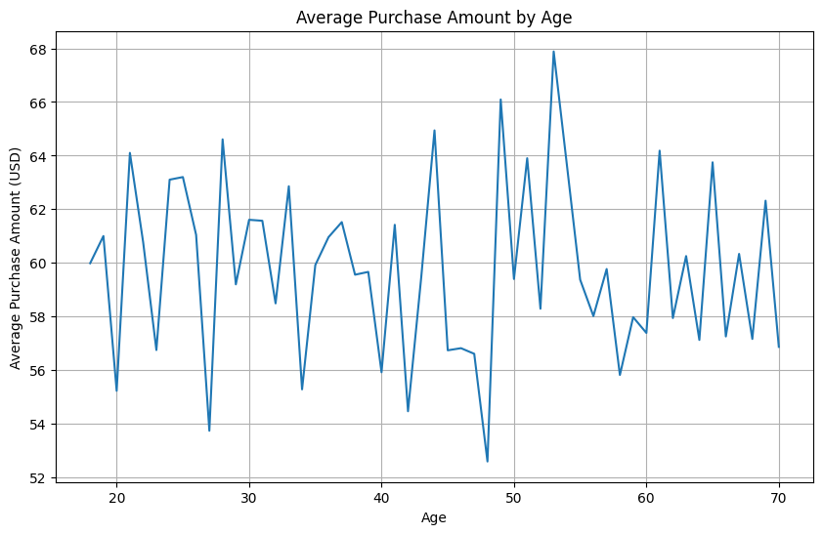

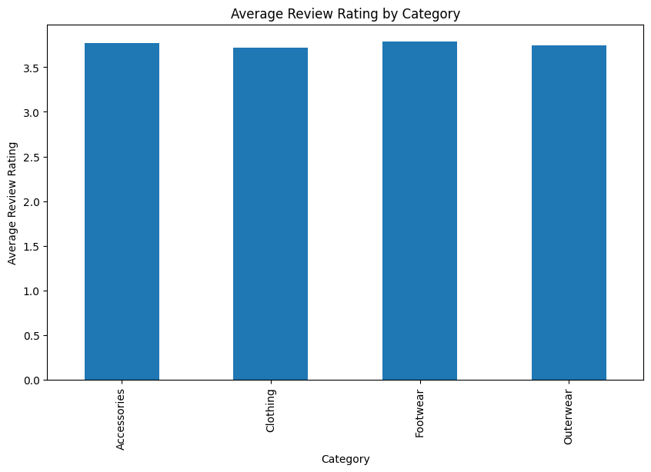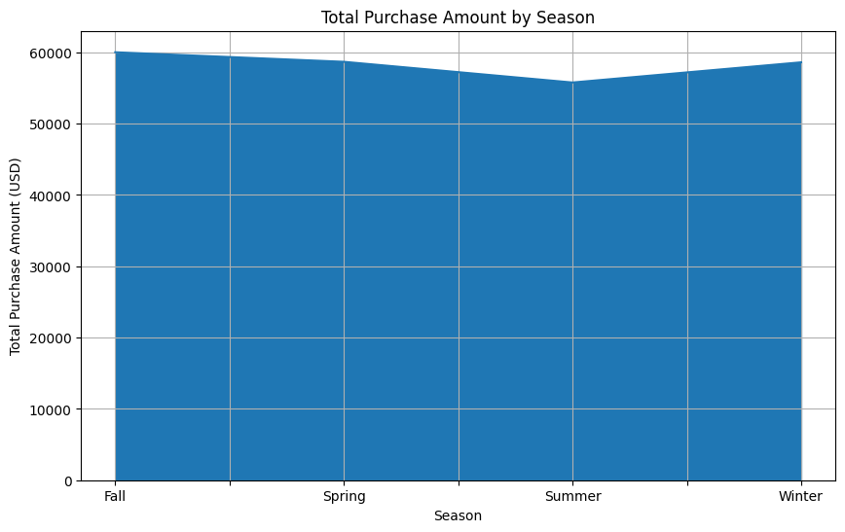

Cleaned data saved to: shopping_trends_cleaned.csv

Classification Report:

precision recall f1-score support

0 0.92 0.81 0.86 558

1 0.63 0.83 0.72 222

accuracy 0.82 780

macro avg 0.78 0.82 0.79 780

weighted avg 0.84 0.82 0.82 780

Accuracy Score: 0.8153846153846154

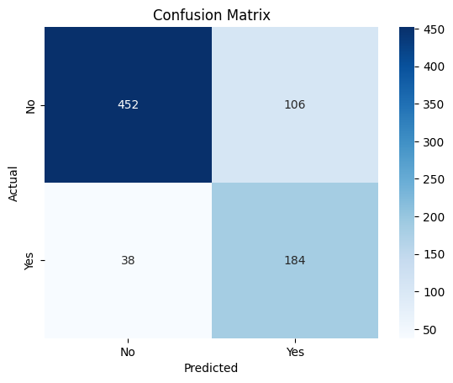

Feature Importances:

Feature Importance

8 Discount Applied 0.408965

1 Purchase Amount (USD) 0.106326

0 Age 0.100002

3 Previous Purchases 0.099473

2 Review Rating 0.088333

4 Gender 0.079090

7 Shipping Type 0.047457

6 Season 0.036807

5 Category 0.033547

<ipython-input-3-bd23d445dd0c>:143: FutureWarning:

Passing `palette` without assigning `hue` is deprecated and will be removed in v0.14.0. Assign the `y` variable to `hue` and set `legend=False` for the same effect.

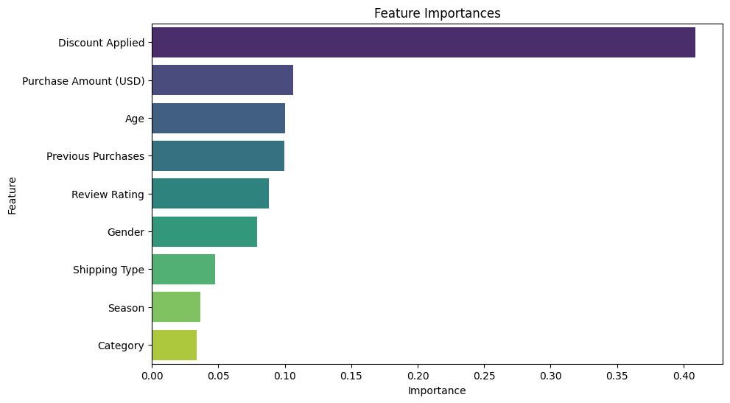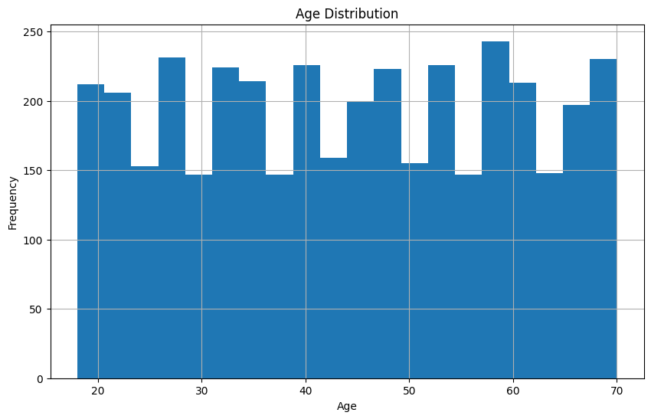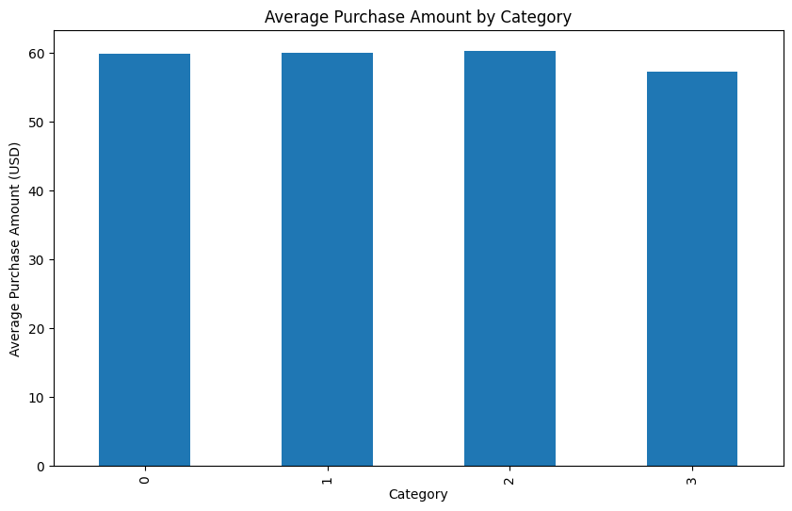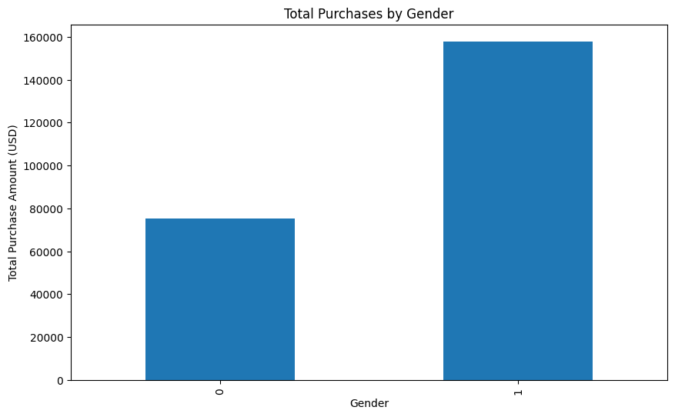

Most Common Items in Each Category:

Category

0 Jewelry

1 Blouse

2 Sandals

3 Jacket

Name: Item Purchased, dtype: object

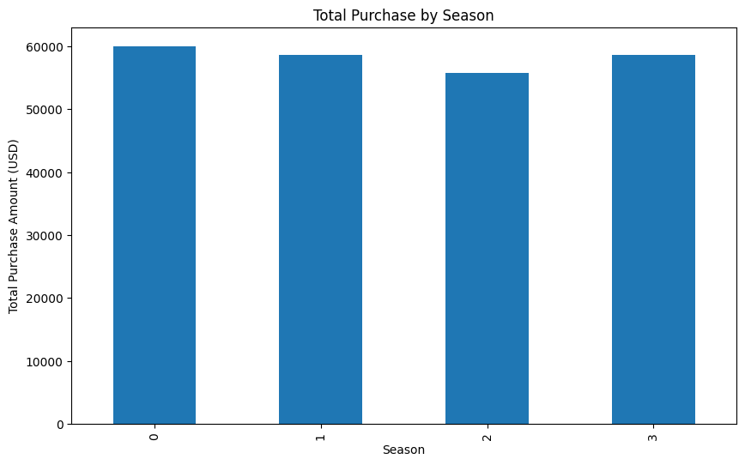

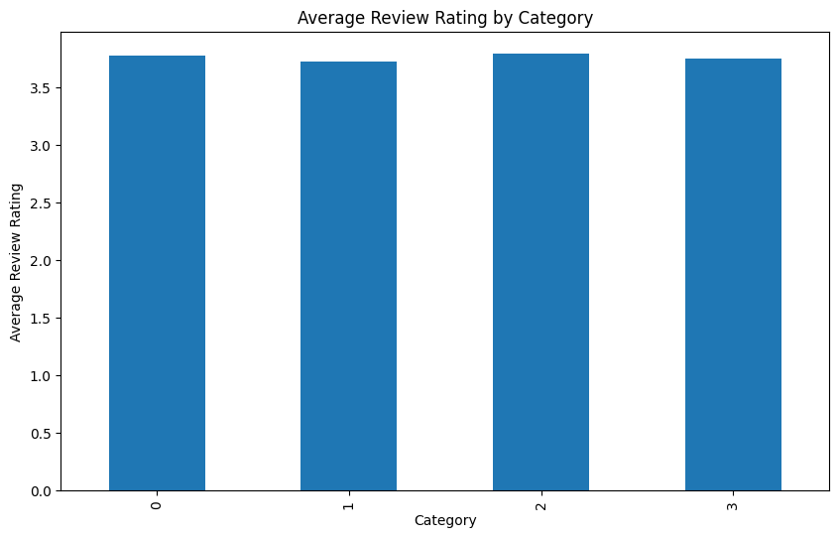

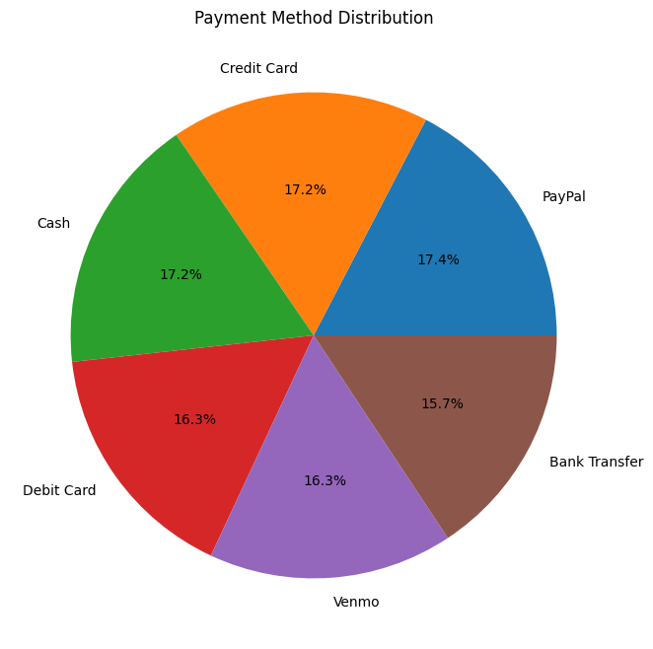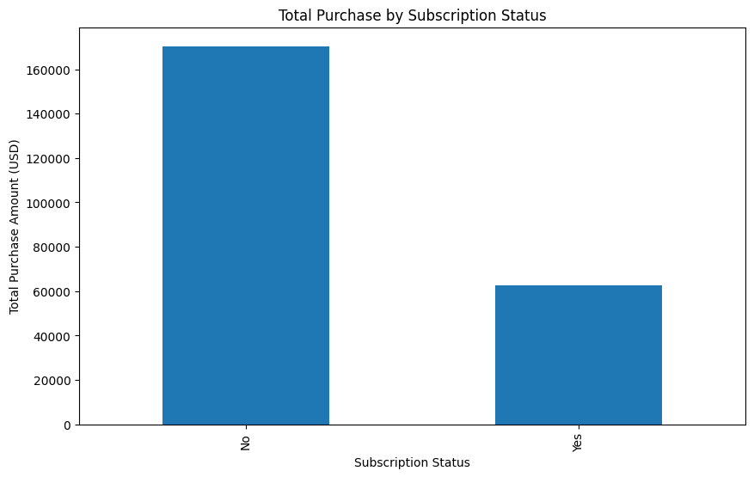

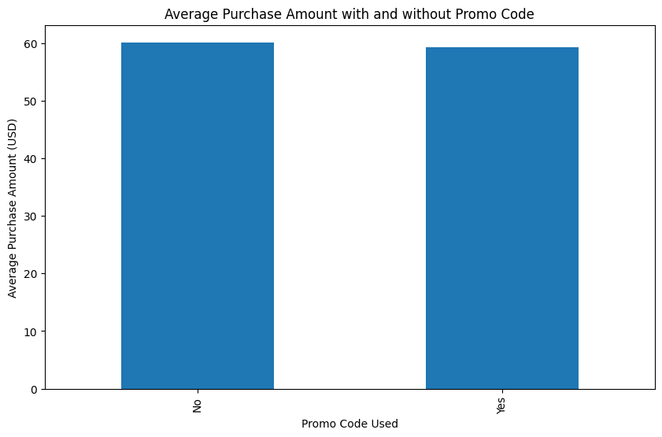 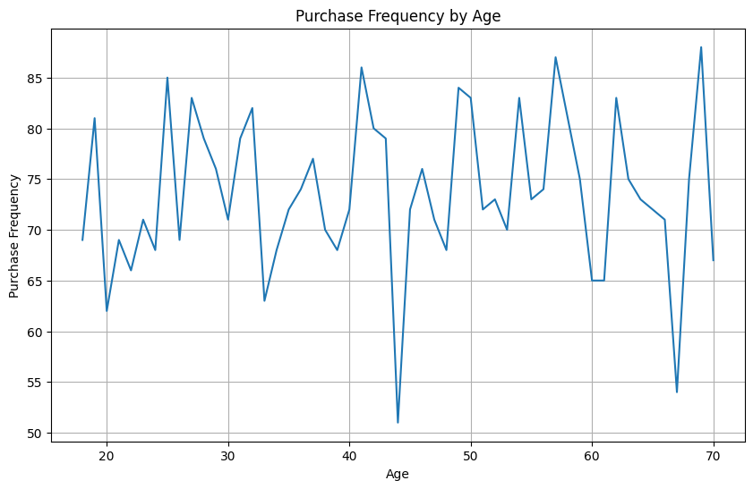

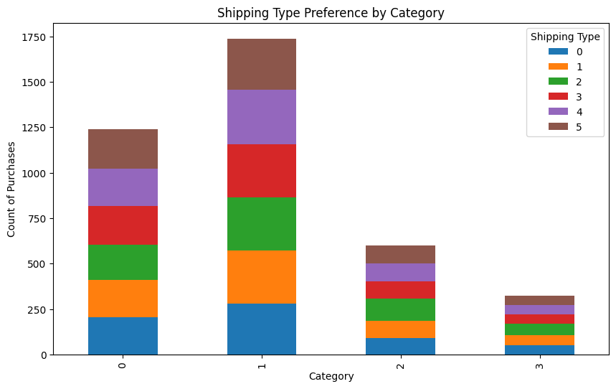

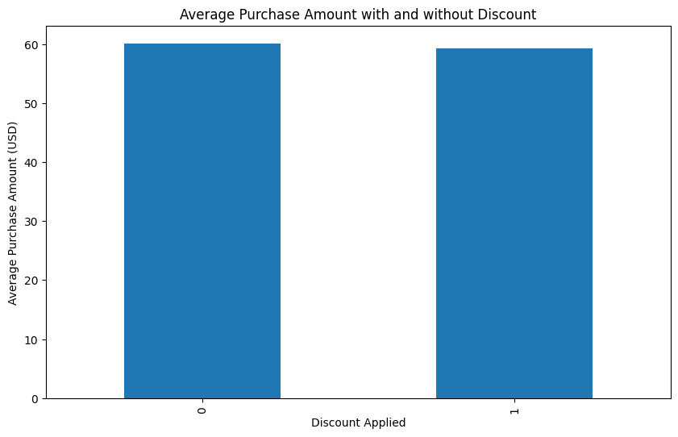

Average Number of Previous Purchases: 25.35153846153846

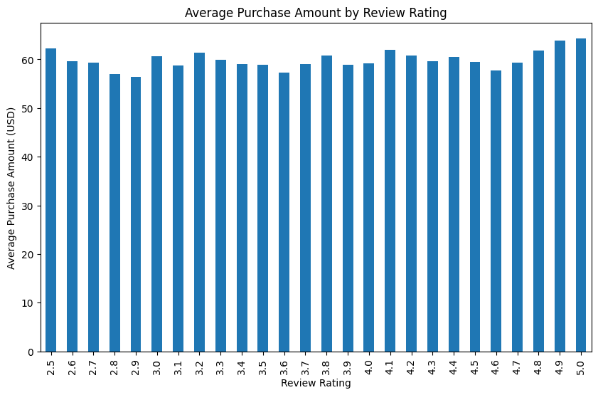

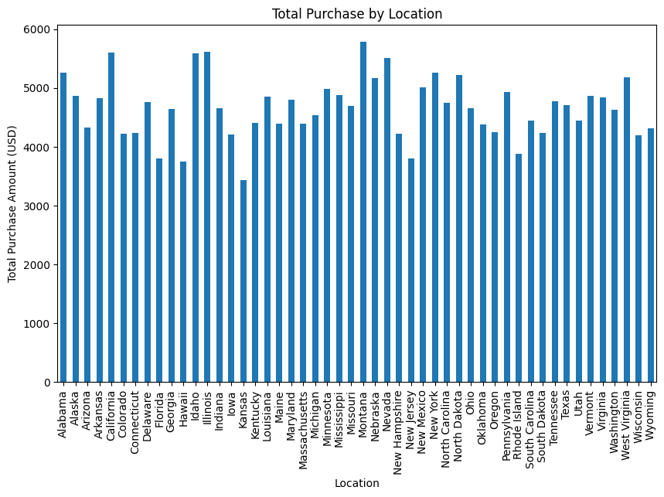

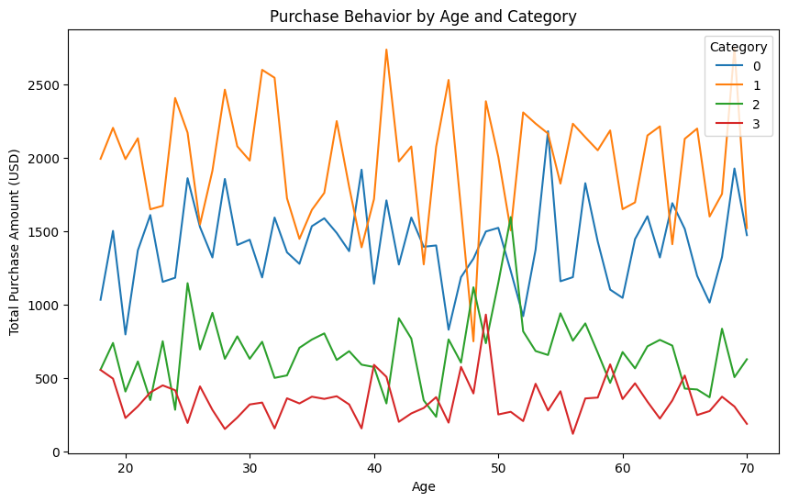

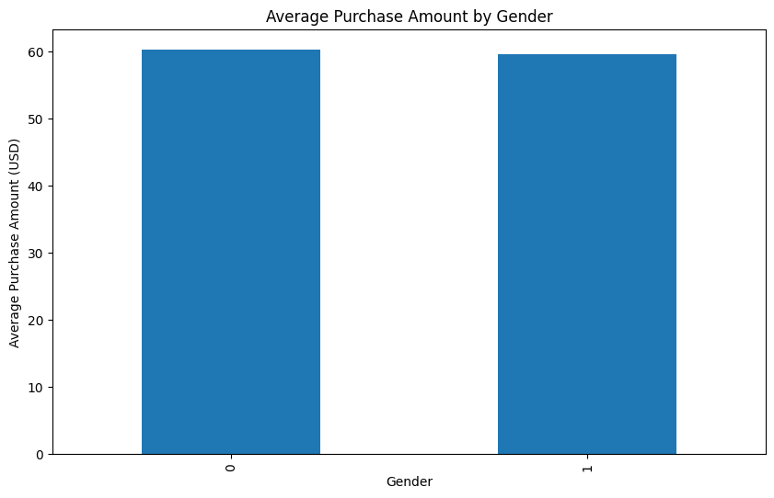

* 1. **. GitHub Link for Code:**

[**LINK**](https://github.com/malini4569/Identify-shopping-trends-Data-Analysis.git)

**CHAPTER 5**

**Discussion and Conclusion**

**5.1 Future Work**

To enhance the effectiveness of the proposed model for identifying shopping trends, the following suggestions can be considered:

**Suggestions for Improvement**

1. Enhanced Data Sources:

Incorporate IoT Data: Utilize data from IoT devices (e.g., smart carts, beacons) to gather real-time consumer behavior insights in physical stores.

Expand Social Media Analysis: Broaden the scope of social media platforms analyzed to include emerging platforms like TikTok and Instagram for a more comprehensive view of consumer sentiment.

2. Advanced Machine Learning Techniques:

Deep Learning Models: Implement advanced deep learning architectures (e.g., LSTM, CNN) for more robust pattern recognition in time-series data.

Reinforcement Learning: Explore reinforcement learning to optimize marketing strategies based on consumer interactions and feedback.

3. Real-time Feedback Loop:

User Feedback Integration: Create mechanisms to gather user feedback on predictions and recommendations, allowing the model to learn and adapt continuously.

4. Scalability Enhancements:

Distributed Computing: Leverage distributed computing frameworks to efficiently process and analyze larger datasets, ensuring scalability as data volume grows.

5. Ethical Considerations:

Bias Mitigation: Implement strategies to identify and mitigate bias in data collection and model predictions, ensuring fairness and inclusivity in recommendations.

6. User Experience Improvements:

Personalization: Enhance user interfaces with more personalized dashboards that cater to individual user needs and preferences.

Interactive Visualizations: Develop more interactive and intuitive visualization tools to help users better understand trends and insights.

Addressing Unresolved Issues

Data Privacy and Security: Further research on data privacy regulations (e.g., GDPR) to ensure compliance while utilizing consumer data.

Handling Missing Data: Develop more sophisticated techniques for managing missing or incomplete data to improve model accuracy.

5.2 Conclusion

The project on identifying shopping trends using data analysis has significant implications for retail businesses and consumer insights. By leveraging diverse data sources and advanced analytical techniques, the proposed solution aims to provide retailers with actionable insights into consumer behavior and preferences.

Overall Impact and Contribution

Informed Decision-Making: The ability to predict shopping trends enables retailers to make data-driven decisions, optimizing inventory management, marketing strategies, and customer engagement.

Enhanced Customer Experience: By understanding consumer preferences, retailers can tailor their offerings, leading to improved customer satisfaction and loyalty.

Contribution to Research: This project contributes to the growing body of knowledge in data analytics, machine learning, and consumer behavior research, providing a framework that can be adapted and expanded upon in future studies.

In summary, the project not only addresses current challenges in trend identification but also lays the groundwork for future advancements in the field, ultimately benefiting both retailers and consumers alike.

**REFERENCES**

[1]. **Wes McKinney**, "Python for Data Analysis," O'Reilly Media, 2nd Edition, 2017.  
[2]. **DataCamp**, "Exploratory Data Analysis using Python," DataCamp, Available at: https://www.datacamp.com/community/tutorials/exploratory-data-analysis-python, 2020.  
[3]. **Real Python**, "Data Preprocessing with Pandas," Real Python, Available at: https://realpython.com/python-data-cleaning-numpy-pandas/, 2020.  
[4]. **Kaggle**, "Exploratory Data Analysis on Kaggle," Kaggle, Available at: https://www.kaggle.com/learn/eda, 2020.  
[5]. **DataCamp**, "Feature Engineering for Machine Learning," DataCamp, Available at: https://www.datacamp.com/community/tutorials/feature-engineering-python, 2020.  
[6]. **Towards Data Science**, "Feature Engineering 101: A Guide for Data Scientists," Towards Data Science, Available at: https://towardsdatascience.com/feature-engineering-for-machine-learning-d7d72b7b5c11, 2019.  
[7]. **Scikit-learn**, "Scikit-learn Documentation," Scikit-learn, Available at: https://scikit-learn.org/stable/documentation.html, 2020.  
[8]. **GitHub**, "Random Forest Classifier Project on GitHub," GitHub, Available at: <https://github.com/justmarkham/DAT8/blob/master/notebooks/03_feature_selection_and_random_forest.ipynb>, 2019.

[9]. **Towards Data Science**, "A Comprehensive Guide to Hyperparameter Tuning," Towards Data Science, Available at: https://towardsdatascience.com/hyperparameter-tuning-with-scikit-learn-68fa2ff7595a, 2019.  
[10]. **Machine Learning Mastery**, "How to Evaluate Machine Learning Models," Machine Learning Mastery, Available at: https://machinelearningmastery.com/compare-machine-learning-algorithms-python-using-resampling/, 2020.  
[11]. **Kunal Sood**, "Data Visualization with Python and Matplotlib," O'Reilly Media, 2021.  
[12]. **GitHub**, "Matplotlib and Seaborn Projects on GitHub," GitHub, Available at: <https://github.com/rougier/matplotlib-tutorial>, 2019.  
[13]. **Kaggle**, "Titanic: Machine Learning from Disaster," Kaggle, Available at: https://www.kaggle.com/c/titanic, 2020.  
[14]. **GitHub**, "Customer Segmentation using K-means Clustering," GitHub, Available at: <https://github.com/nikbearbrown/Customer-Segmentation>, 2020.  
[15]. **Towards Data Science**, "Customer Segmentation with Python," Towards Data Science, Available at: https://www.datacamp.com/community/tutorials/customer-segmentation-python, 2019.  
[16]. **Towards Data Science**, "A Comprehensive Intuitive Guide to XGBoost," Towards Data Science, Available at: https://towardsdatascience.com/a-comprehensive-intuitive-guide-to-xgboost-92f6b16bace9, 2020.  
[17]. **Coursera**, "Deep Learning Specialization by Andrew Ng," Coursera, Available at: <https://www.coursera.org/specializations/deep-learning>, 2021.  
[18]. **Towards Data Science**, "How to Deploy a Machine Learning Model," Towards Data Science, Available at: https://towardsdatascience.com/deploying-your-machine-learning-model-as-an-api-37ec7e773041, 2019.  
[19]. **Coursera**, "Deploying Machine Learning Models on AWS," Coursera, Available at: <https://www.coursera.org/learn/machine-learning-with-aws>, 2020**.**